Q1. Write a program to create 3 Checkboxes with your favourite Subjects c,c++ and Java. Dislay all the status of those checkboxes as True if selected otherwise false in AWT.

🡪

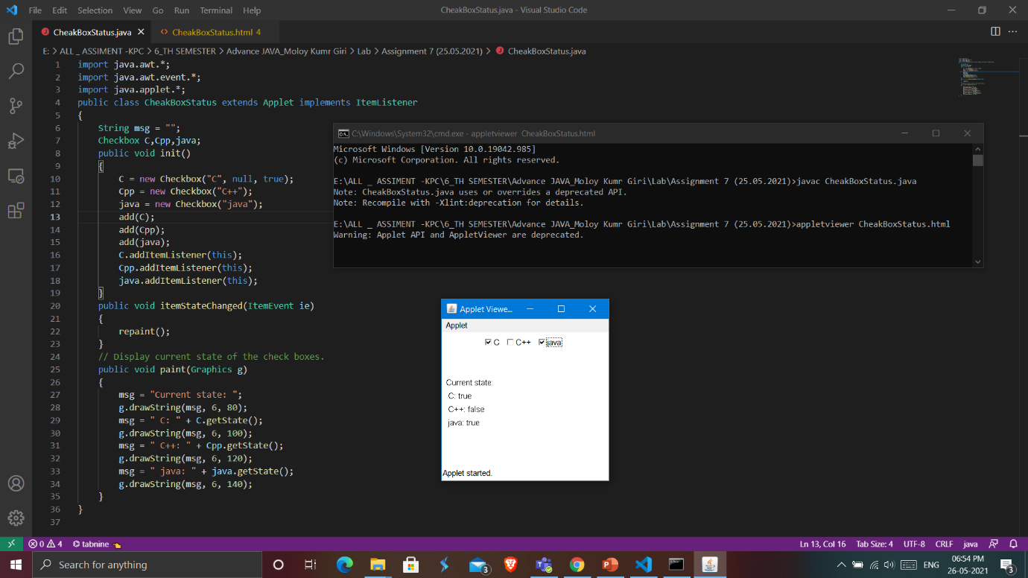

Q2. Write a program to create one text field and one password field with character (@) display text field value, selected value and password value in AWT.

🡪

